The Izhikevich Spiking Neuron Model
Neurons are cells that make up most of the nervous system. An adult human brain weights approximately 1.3 Kg and includes 100 billion neurons. Morphologically, nerve cells have three main components: the soma, or the cell body, the axon and the dendrites. Dendrites collect impulses from other neurons, and broadcast these pulses to the soma where, if the generated potential is high enough, a spike is triggered. The neuron’s axon then communicates signals to other neurons (approximately, each neuron is connected to other 10,000 neurons).
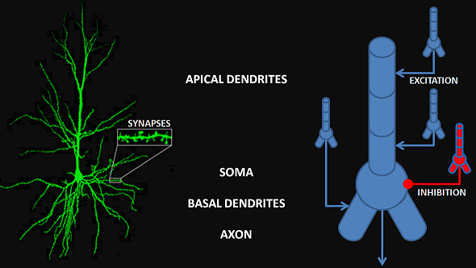
Neurons process and transfer information in the form of electrical pulses (spikes) traveling down their axons and resulting in neurotransmitter release of excitatory, inhibitory or modulatory neurotransmitters at the synapse with another neuron, usually at the receiving cell’s dendrites or soma. There are three broad classes of neurons based on their effect on other neurons’ membrane potential: excitatory, inhibitory and modulatory neurons. Complex networks of these neurons form the computational backbones of the nervous system. Whereas excitatory inputs, summing at the cell body, bring the cell closer to its firing threshold, inhibitory cells bring the cell further from its firing threshold. Excitation and inhibition are the main ingredients of cell communication and information processing in the nervous system, where processes such as cell competition, short-, and long-term memory depend on a delicate balance between these two components. Neuromodulation acts by modifying this balance: neurotransmitters such as dopamine, acetylcholine and serotonin modify cell’s excitability, broadening a cell’s behavior in a state-dependent way.
Research in neuroscience has progressively captured more and more details on the morphology and biophysics of neurons. At the same time, computational neuroscientists have synthesized scores of data and cell recordings in computational models that are simple enough to be implemented on regular computers. Since it is believed that neurons’ main communication “alphabet” consists of trains of spikes caused by fluctuations in the cell membrane potential, computational neuroscientists have focused on mathematically characterizing these electrical fluctuations.
In this microassembly, we will look at a simple and powerful model proposed by Eugene Izhikevich in 2003 (http://www.izhikevich.org/publications/spikes.pdf). This mathematical model is the most recent of a long tradition of models used to study individual neurons that display spiking/bursting behavior. Examples of these models include among others Hodgkin-Huxley, and FitzHugh-Nagumo. The Izhikevic model is particularly interesting because it is a compact model that, via a suitable change of parameters, can simulate a large array of neurons’ behavior.
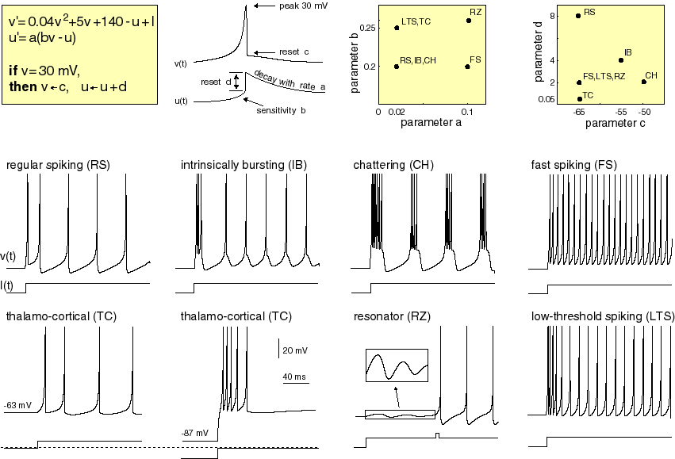
The Izhikevich model consists of a system of two differential equations. The two variables in the system are the following: v denotes the membrane potential of a neuron in millivolts (mV), while u denotes the generic recovery variable. There are also five free parameters in the equation:
I the external input to the neuron, such as those from synaptic inputs
a the rate of recovery of u
b the ‘sensitivity of recovery to subthreshhold fluctuations of membrane potential’
c, d are the after spike resets of v and u respectively, i.e. the values to which they get set back after a spike occurs.
The Izhikevich equation is as follows:
v’=0.04*v^2+5*v+140-u+I
u’=a*(b*v-u)
together with the following reset conditions:
if v>=30 then:
v:=c
u:=u+d
(i.e. in the case that the membrane potential v, becomes greater than 30 mV the neuron spikes the variables get reset to values determined by the parameters, so the neuron may spike again).
In the Matlab code provided, we will be solving the Izhikevich equations numerically using Euler’s method. By manually changing the parameters of the equation, it is possible to reproduce all the spiking behaviors shown in the figures above. But be careful, if you randomly change the parameters, your model may no longer have any biological meaning!

